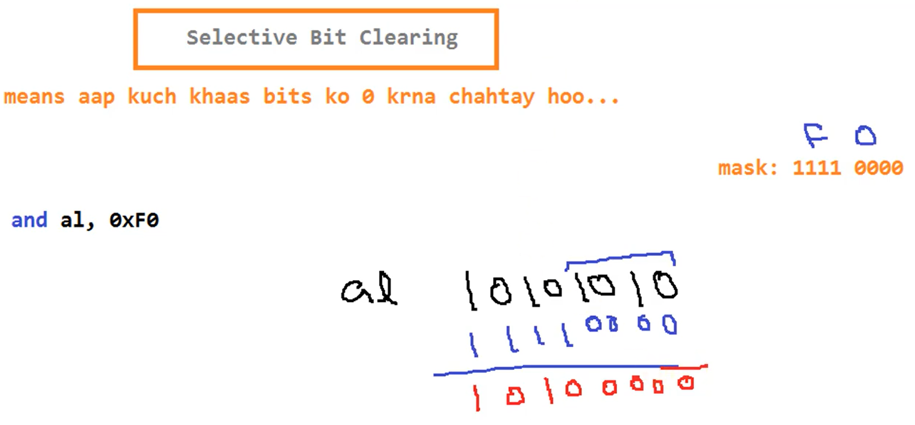

Write a program to swap every pair of bits in the AX register.

[org 0x0100]

jmp start

num: dw 1500

swap: dw 0

start: mov ax, [num]

mov bx, ax

mov cx, ax

and bx, 0x5555 ; Extract odd bits

and cx, 0xAAAA ; Extract even bits

shl bx, 1 ; Shift odd bits to even places

shr cx, 1 ; Shift even bits to odd places

mov ax, 0

or ax, cx

or ax, bx

mov [swap], ax

mov ax, 0x4c00

int 0x21

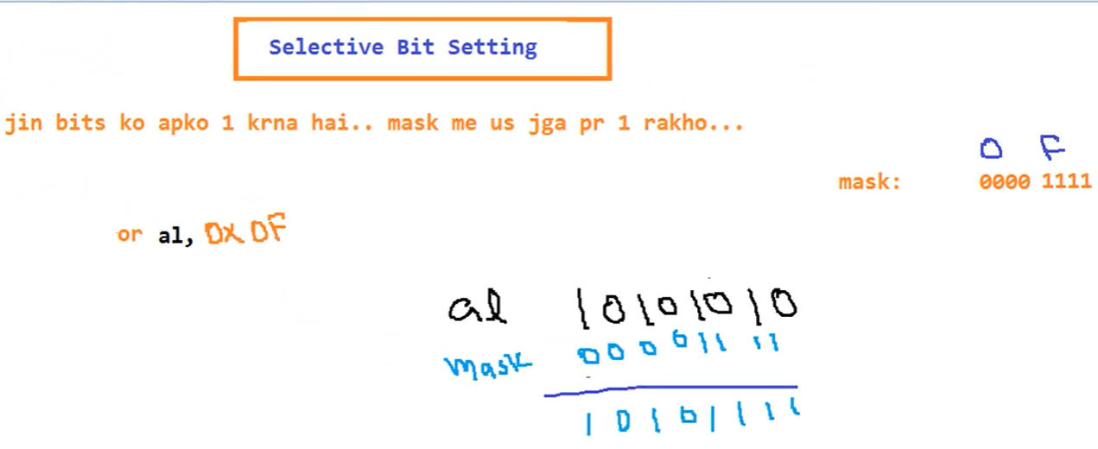

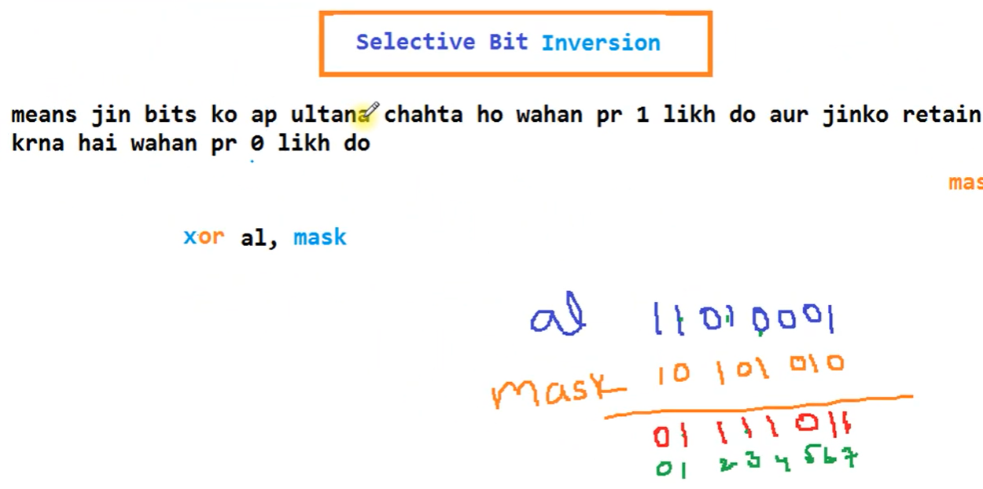

Inverting Even bits using **XOR**

